PENETRATION TESTING REPORT
FOOTPRINTING & NETWORK SCANNING PHASES
W2-PM-FINAL | CYBERSECURITY | NETWORKWALKS

Pentester Name  (Cybersecurity Professional) | Stefan Andrei Florin
Program/Batch | B084J-Networkwalks
Date | 13 Nov 2026
Modules completed | - W2-PM1 – Footprinting with Multiple Kali Linux Tools  - W2-PM2 – Footprinting with Google Hacking Database (GHDB)  - W2-PM3 – Footprinting with Maltego  - W2-PM4 – Footprinting with theHarvester  - W2-PM5 – Network Scanning with Zenmap  All modules completed
Client/Target | 1. Networkwalks (secured written permission already)  2. My own local LAN Network
Permission secured from client? | Yes
Phases covered | Phase 1: Reconnaissance & Footprinting  Phase 2: Scanning & Network Discovery  Phase 3-5: Completed

1. Liability Disclaimer
I have performed these activities only on systems and devices for which I had secured written permission or on devices and networks that I personally own.
All activities described in this report were conducted for educational, training, and cybersecurity research purposes.
The knowledge and techniques presented in this report must not be used for unauthorized access, malicious activities, or any actions that violate applicable laws.
The instructor, authors, and Networkwalks are not responsible for any misuse of the information presented in this report. Every action taken using this knowledge is the responsibility of the individual performing it.
Unauthorized access to computer systems and networks is a criminal offense in many countries, even when no damage is caused.

2. Introduction
This report documents the practical cybersecurity activities completed during Week 2 of my Cybersecurity and Ethical Hacking internship program at Networkwalks.
The main objective of this week's practical assignments was to understand how penetration testers collect information about a target before performing more advanced security assessments.
The report covers five practical modules, focusing on different reconnaissance, footprinting, and network discovery techniques.
During these exercises, I used several cybersecurity tools and techniques to gather information about the target environment and identify devices connected to my own local network.
The five modules covered in this report are:
- W2-PM1: Footprinting with Multiple Kali Linux Tools.
- W2-PM2: Footprinting using the Google Hacking Database (GHDB).
- W2-PM3: Footprinting and information gathering using Maltego.
- W2-PM4: Information gathering using theHarvester.
- W2-PM5: Network scanning and host discovery using Zenmap.
These practical exercises helped me understand how publicly available information can be collected, analyzed, and organized to build a better understanding of a target's digital infrastructure.
All activities were performed using Kali Linux, Windows, and the tools required by the practical assignments.
Each module includes a description of the activities performed, the tools used, the observations made, and the potential security implications of the information collected.

3. Tools Used
The following tools and technologies were used throughout the five practical modules.
Tool | Purpose
Kali Linux | Operating system used for reconnaissance and footprinting activities.
WHOIS | Collect publicly available domain registration information.
WhatWeb | Identify website technologies, CMS platforms, and web server information.
Nslookup | Resolve domain names into IP addresses using DNS.
cURL | Inspect HTTP response headers and website responses.
Wafw00f | Identify whether a Web Application Firewall protects a website.
DNSRecon | Enumerate DNS records and collect DNS infrastructure information.
Google Hacking Database (GHDB) | Identify publicly indexed information using specialized Google search queries.
Google Dorks | Search for exposed files, directories, login pages, and other publicly indexed information.
Maltego | Visualize relationships between domains, IP addresses, DNS records, and other entities.
theHarvester | Collect publicly available information such as email addresses, subdomains, and associated domains.
Zenmap | Graphical interface for Nmap used to discover live hosts and map network infrastructure.
Nmap | Perform network discovery and identify active devices.
Windows CMD | Identify local network configuration, IP addresses, and MAC addresses.

4. Activities Performed

4.1 Footprinting with Multiple Kali Linux Tools (W2-PM1)
For the first practical module, I performed footprinting and reconnaissance activities against the Networkwalks domain using multiple tools available in Kali Linux.
The objective was to understand how different tools can collect information about a website and its underlying infrastructure.
I used WHOIS to obtain publicly available domain registration information, including registration details and name server information.
Next, I used WhatWeb to identify the technologies and content management systems used by the target website.
I also used Nslookup to resolve the domain name and identify its associated IP address.
Using cURL with the -I option, I inspected the HTTP response headers to identify information returned by the web server.
I then used Wafw00f to check whether a Web Application Firewall was present and identify the technology protecting the website.
Finally, I used DNSRecon to enumerate DNS records and collect information about name servers, mail servers, TXT records, and other DNS-related information.
These activities demonstrated how multiple reconnaissance tools can be combined to build an initial technical profile of a website.

4.2 Footprinting with Google Hacking Database (W2-PM2)
For the second practical module, I explored the Google Hacking Database (GHDB) and learned how Google search operators, also known as Google Dorks, can be used during reconnaissance.
The main objective was to understand how search engines can reveal information that is publicly indexed and potentially exposed by websites.
I used specialized search queries to investigate publicly available information associated with the target environment.
Google Dorks can help security professionals identify publicly indexed files, exposed directories, login pages, document files, and other information that may not be immediately visible through normal website navigation.
The practical exercise helped me understand how search engines can be used as an information-gathering resource during the reconnaissance phase.
I also learned that publicly indexed information should be reviewed carefully because sensitive documents or configuration files may sometimes become accessible due to incorrect website configurations.
All searches were conducted within the authorized educational scope of the practical assignment.

4.3 Footprinting with Maltego (W2-PM3)
For the third practical module, I used Maltego to perform visual reconnaissance and investigate relationships between different digital entities.
Maltego is an OSINT tool that helps security professionals collect, analyze, and visualize publicly available information.
During this activity, I explored how information related to domains, IP addresses, DNS records, websites, and other entities can be represented through a graphical link analysis.
I used Maltego transforms to collect and expand information about the selected target.
The graphical representation helped me understand how different entities can be connected and how information collected from one source can lead to additional discoveries.
This practical exercise demonstrated the importance of relationship mapping during reconnaissance.
By organizing collected information into a visual graph, a penetration tester can obtain a clearer overview of a target's digital footprint and identify areas that may require further investigation.

4.4 Footprinting with theHarvester (W2-PM4)
For the fourth practical module, I used theHarvester to collect publicly available information associated with the target domain.
TheHarvester is an OSINT tool commonly used during the reconnaissance phase to identify information such as:
- Email addresses.
- Subdomains.
- Associated domains.
- Publicly available hostnames.
- Information collected from supported search engines and public sources.
I used the tool to perform information gathering against the selected target within the authorized scope of the practical exercise.
The results helped demonstrate how publicly available sources can reveal information about an organization's digital infrastructure.
Email addresses and subdomains can be particularly useful during security assessments because they provide additional information about an organization's online presence.
This exercise helped me understand how automated OSINT tools can make the information-gathering process more efficient.
It also demonstrated why organizations should regularly review their publicly exposed digital information.

4.5 Network Scanning with Zenmap (W2-PM5)
For the fifth practical module, I used Zenmap, the graphical interface for Nmap, to perform network discovery on my own local network.
The main objective was to identify active devices connected to the local network and understand how network scanning can help map an internal environment.
I first used the Windows ipconfig command to identify my local IP address, subnet mask, and default gateway.
After identifying the network range, I entered the appropriate subnet into Zenmap and selected the Ping Scan option.
The scan was used to discover active hosts within the local network.
I then reviewed the scan results to identify responding devices, their IP addresses, and available MAC address information.
After completing the network discovery activity, I used the Topology section in Zenmap to visualize the discovered network environment.
I also enabled the topology legend and saved the generated network topology as a PDF document.
This practical exercise helped me understand how network discovery works and how penetration testers can identify devices connected to an internal network.
It also demonstrated the importance of maintaining an accurate inventory of network devices.

5. Risk Analysis / Impact
Based on the activities performed during the five practical modules, I identified several potential security risks associated with publicly available information and internal network discovery.
# | Risk / Finding | Evidence / Observation | Potential Impact | Risk Level
1 | Web technology information exposed | PM1 – Website technologies identified using WhatWeb. | Attackers may use technology information to identify software requiring further security assessment. | Medium
2 | Domain registration information available | PM1 – WHOIS information collected. | May reveal information about domain registration and infrastructure. | Low
3 | DNS infrastructure information exposed | PM1 – DNS records collected using DNSRecon. | May help attackers build a profile of the organization's infrastructure. | Medium
4 | HTTP technical information exposed | PM1 – HTTP response headers inspected using cURL. | May assist attackers in identifying website technologies and services. | Low
5 | Publicly indexed information | PM2 – Google Dorks used to investigate indexed resources. | Sensitive information may be exposed if files or directories are incorrectly configured. | Medium
6 | Digital infrastructure relationships identifiable | PM3 – Maltego used to visualize relationships between entities. | May help attackers understand connections between publicly visible infrastructure components. | Medium
7 | Email addresses and subdomains discoverable | PM4 – theHarvester used for OSINT information gathering. | May increase the risk of phishing, targeted attacks, and further reconnaissance. | Medium
8 | Multiple live devices discoverable | PM5 – Zenmap used to identify active hosts on the local network. | Unknown or unauthorized devices may potentially be present on the network. | Medium
Risk Level Key:
- Critical – Immediate and significant security concern.
- High – Significant potential security impact.
- Medium – Requires investigation and appropriate security controls.
- Low – Limited potential impact under normal circumstances.
The risks listed above represent potential security concerns identified through reconnaissance and network discovery activities. They do not confirm the existence of exploitable vulnerabilities.
The practical assignments primarily focused on information gathering, OSINT, footprinting, and host discovery.
No exploitation or vulnerability validation was performed as part of these five modules.
Therefore, further authorized security testing would be required to confirm whether any of the observations represent actual vulnerabilities.

6. Recommendations
Based on the information gathered during the five practical modules, I recommend the following security improvements:
1. Review publicly exposed website technologies
Organizations should regularly review the information publicly exposed by their websites, including CMS platforms, plugins, and server technologies.
2. Keep software and plugins updated
Content management systems, plugins, and web server technologies should be updated regularly to reduce exposure to known vulnerabilities.
3. Review publicly indexed information
Organizations should periodically use search engine operators to identify sensitive files, documents, directories, or other resources that may have been unintentionally indexed.
4. Protect sensitive information
Confidential documents, internal files, configuration files, and sensitive resources should never be publicly accessible without proper authorization.
5. Monitor the organization's digital footprint
Organizations should regularly review their publicly visible domains, IP addresses, subdomains, and associated infrastructure.
6. Review relationships between digital assets
OSINT tools such as Maltego can help organizations understand their digital infrastructure and identify potentially unnecessary public exposure.
7. Protect employee email addresses
Organizations should implement email security controls, phishing awareness training, and appropriate monitoring to reduce the risk of targeted attacks.
8. Review publicly exposed subdomains
Organizations should regularly identify and review their subdomains to ensure that unused or unnecessary services are not publicly accessible.
9. Perform regular internal network discovery
Network administrators should periodically scan their internal networks to identify active devices and maintain an updated inventory.
10. Investigate unknown devices
Any unexpected device discovered during network scanning should be investigated to determine whether it is authorized to connect to the network.
11. Maintain accurate network documentation
Network topology, IP addresses, MAC addresses, and connected devices should be documented and updated regularly.
12. Perform security assessments with authorization
All reconnaissance, OSINT, and network scanning activities should be conducted only within an approved scope and with appropriate authorization.

7. Conclusion
During Week 2 of my Cybersecurity and Ethical Hacking internship at Networkwalks, I completed five practical modules covering footprinting, reconnaissance, OSINT, and network scanning.
In the first module, I used multiple Kali Linux tools to collect information about a target domain. I learned how WHOIS, WhatWeb, Nslookup, cURL, Wafw00f, and DNSRecon can help identify publicly available information about a website and its infrastructure.
In the second module, I explored the Google Hacking Database and learned how Google Dorks can be used to identify publicly indexed information and resources.
In the third module, I used Maltego to visualize relationships between different digital entities and understand how OSINT information can be organized into a graphical representation.
In the fourth module, I used theHarvester to collect publicly available information such as email addresses, subdomains, and associated domains.
In the fifth module, I used Zenmap to perform network discovery on my own local network. I learned how to identify active hosts, review IP and MAC address information, and generate a network topology.
Together, these five practical exercises helped me understand the importance of reconnaissance and information gathering in penetration testing.
I learned that a security professional can collect a significant amount of information about an organization's digital presence before performing any active security testing.
I also understood that different tools provide different types of information, and combining their results can help create a more complete picture of a target environment.
Finally, these activities reinforced the importance of responsible cybersecurity practices, accurate technical documentation, and obtaining proper authorization before performing any security assessment.

8. Evidences Collected
The following screenshots and files should be included as evidence of the practical activities completed during Week 2.
W2-PM1 – Footprinting with Multiple Tools
- WHOIS command and results.
- WhatWeb command and results.
- Nslookup command and results.
- cURL HTTP headers.
- Wafw00f detection results.
- DNSRecon enumeration results.
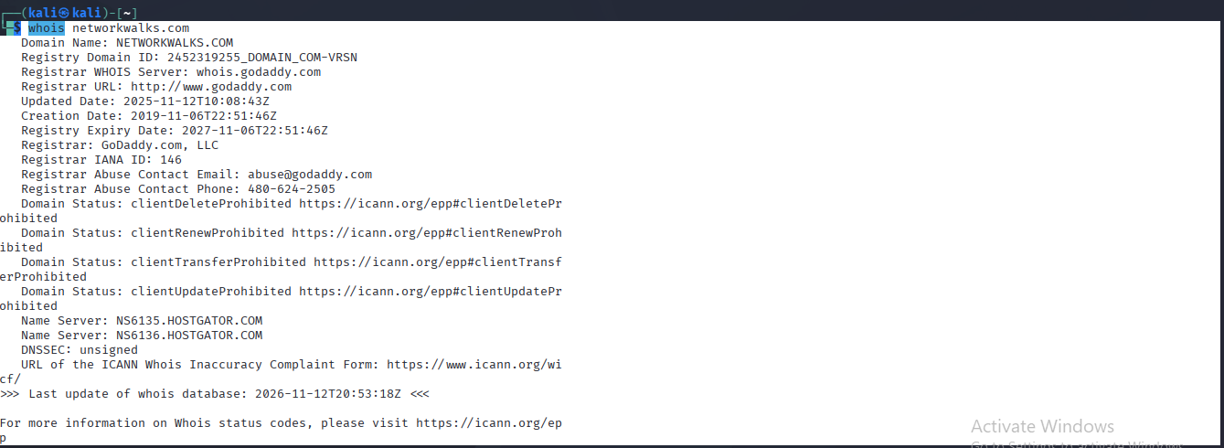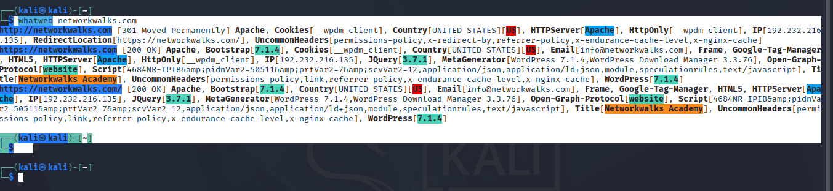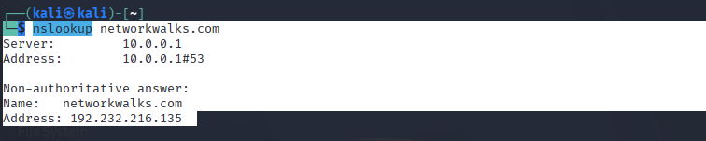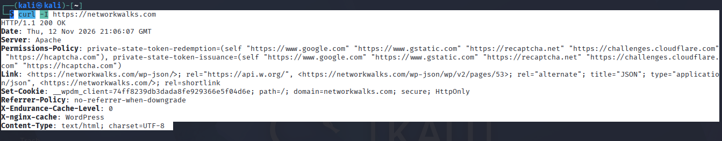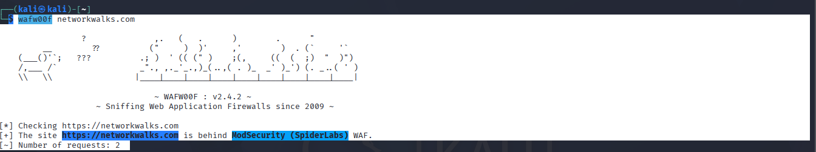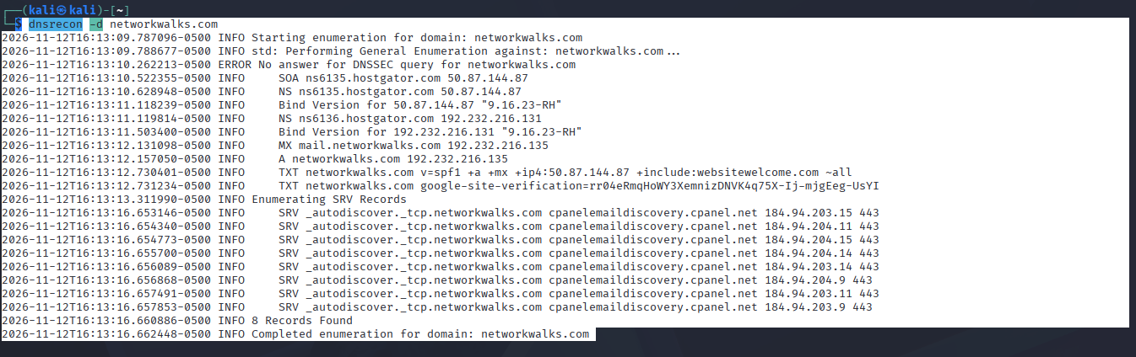
W2-PM2 – Footprinting with GHDB
- Google Hacking Database reference.
- Google Dork search queries.
- Search results obtained during the practical exercise.
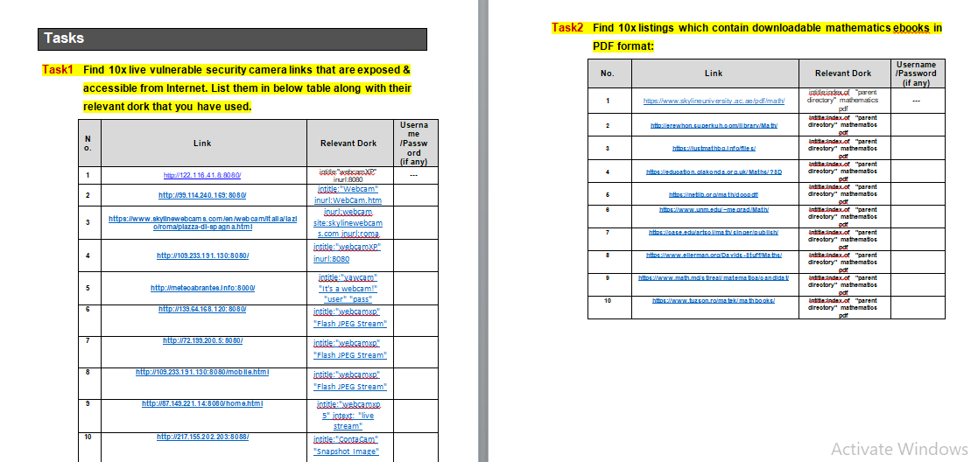
W2-PM3 – Footprinting with Maltego
- Maltego project and selected target.
- Transform execution results.
- Graph showing discovered entities and relationships.
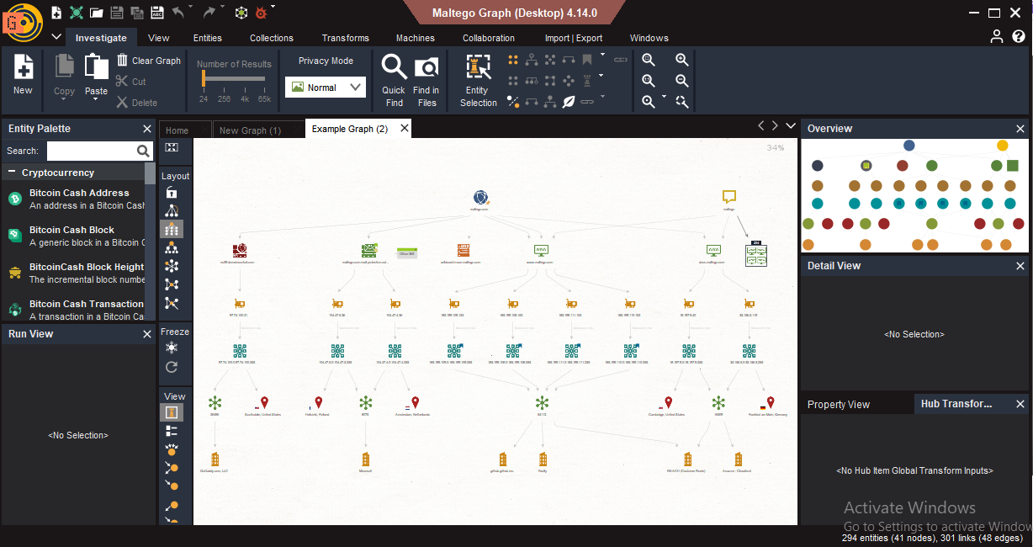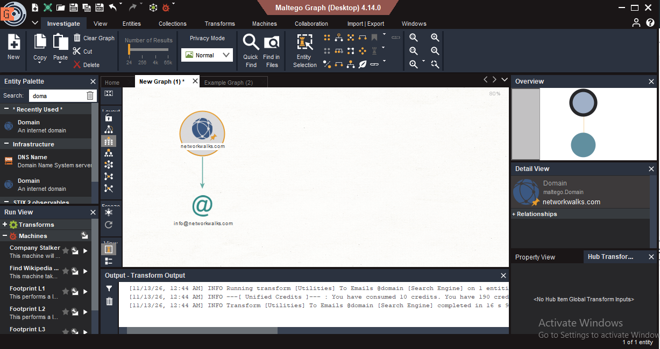
W2-PM4 – Footprinting with theHarvester
- theHarvester commands used.
- Email addresses discovered, where applicable.
- Subdomains and hostnames identified.
- Final information-gathering results.
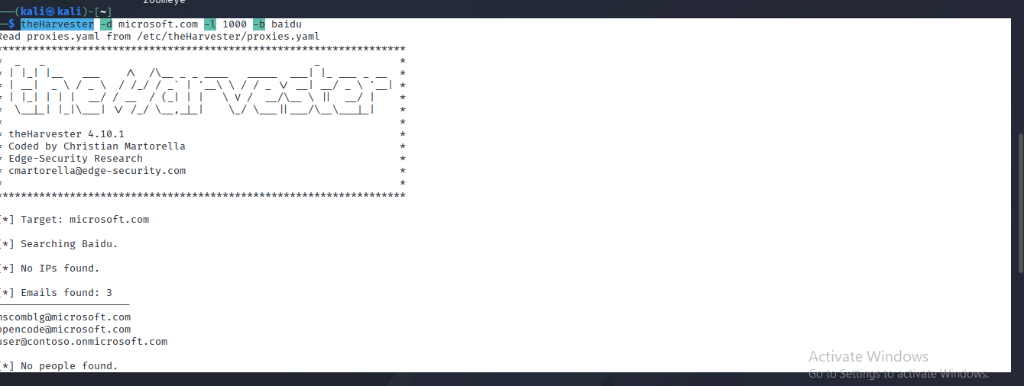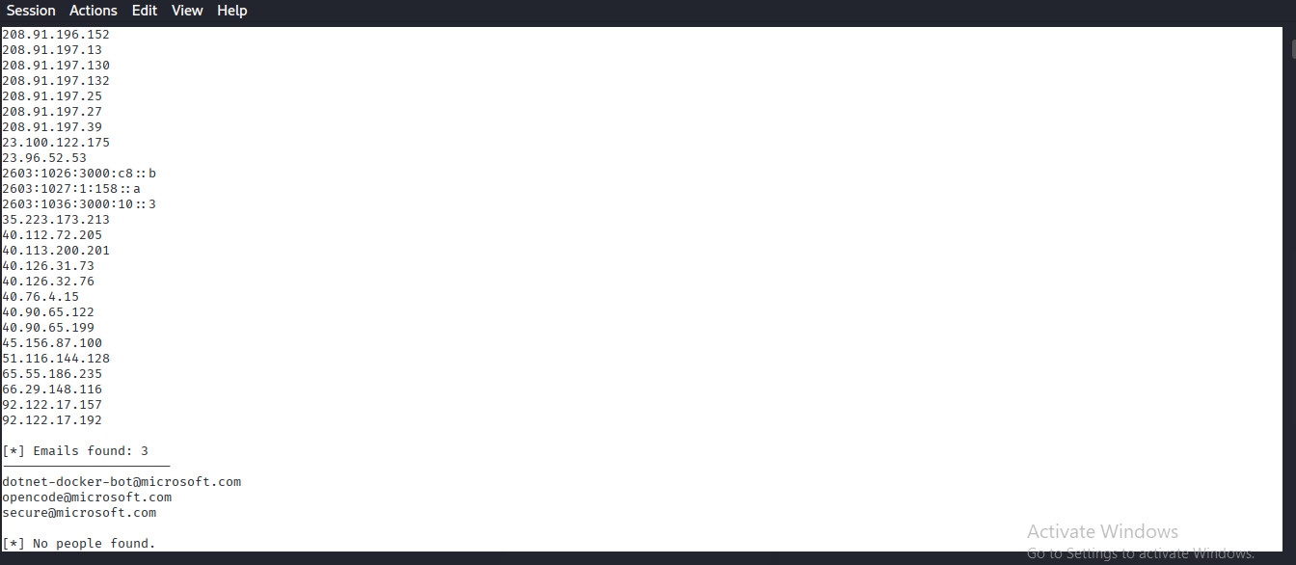
W2-PM5 – Network Scanning with Zenmap
- Windows IP configuration using CMD.
- Zenmap scan configuration.
- Ping Scan results.
- Discovered hosts and network information.
- Network topology.
- Exported network topology PDF.
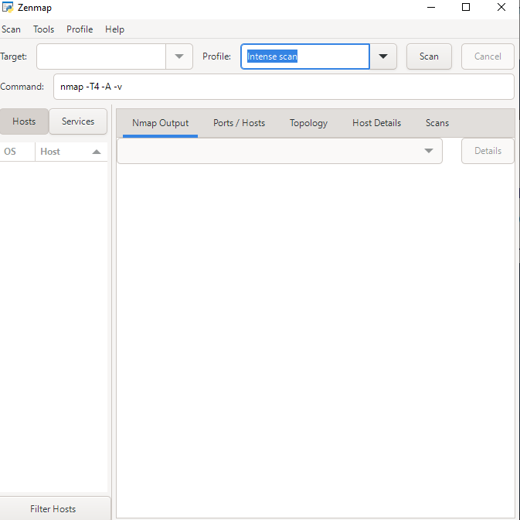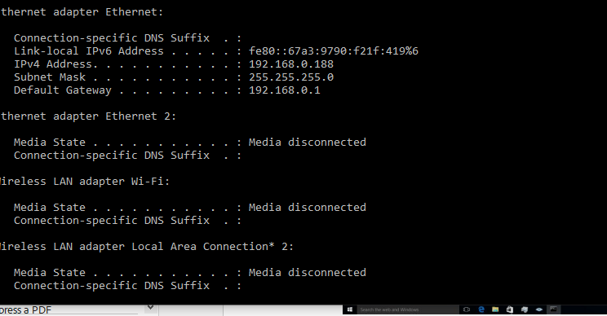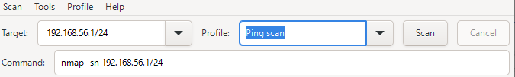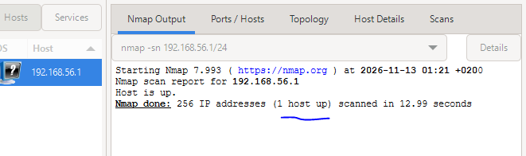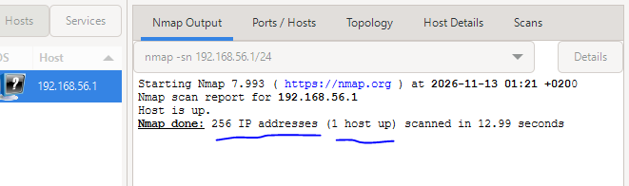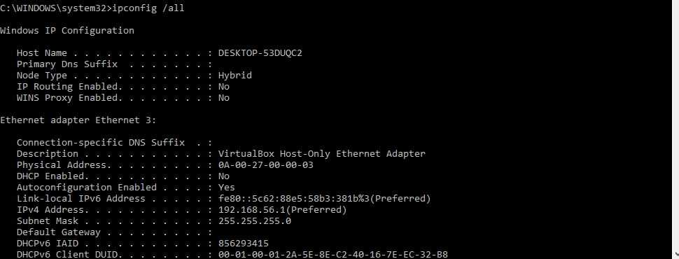
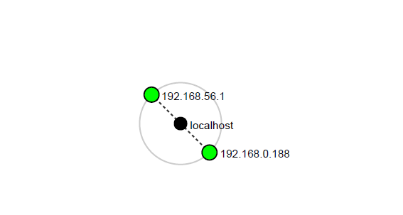
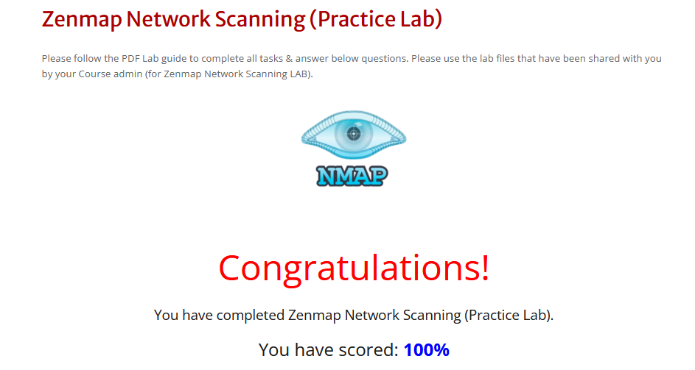
All screenshots and exported files should be attached to the final report to demonstrate the activities performed.

END OF REPORT
Author: Stefan Andrei Florin
Program: Cybersecurity Program at Networkwalks
Batch: B084J
Week: 02
Project: W2-PM-FINAL – Penetration Testing Report
Repository: GitHub : https://github.com/andreyS30
LinkedIn: https://www.linkedin.com/in/stefan-andrei-b91223155

